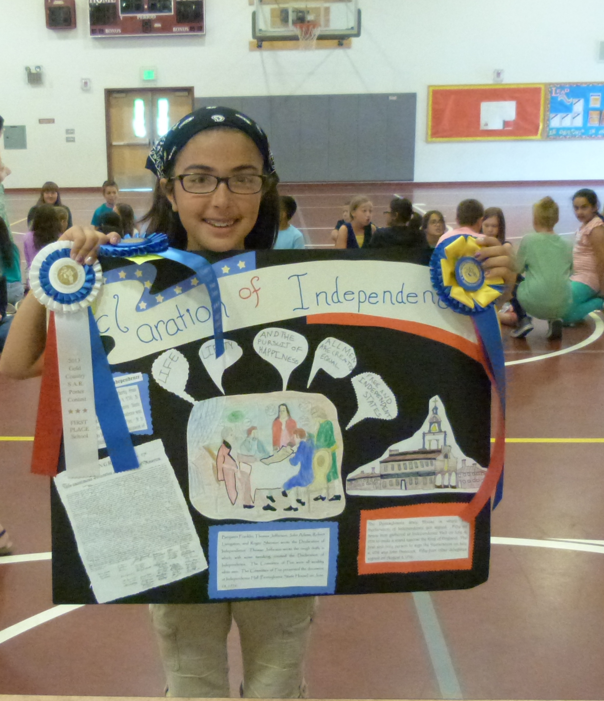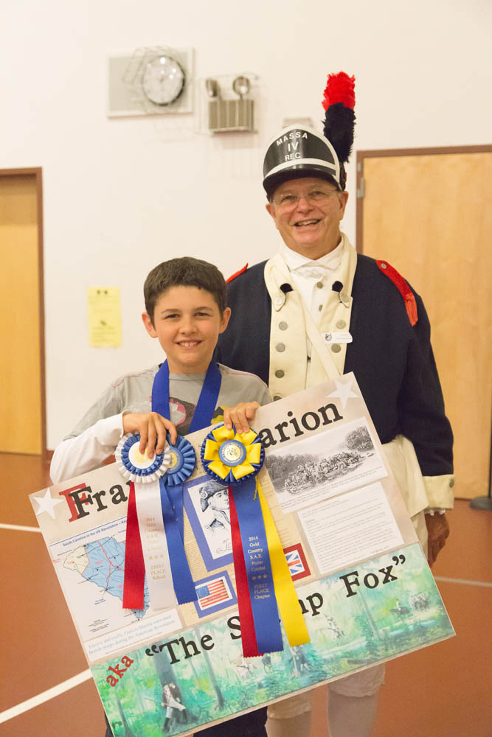  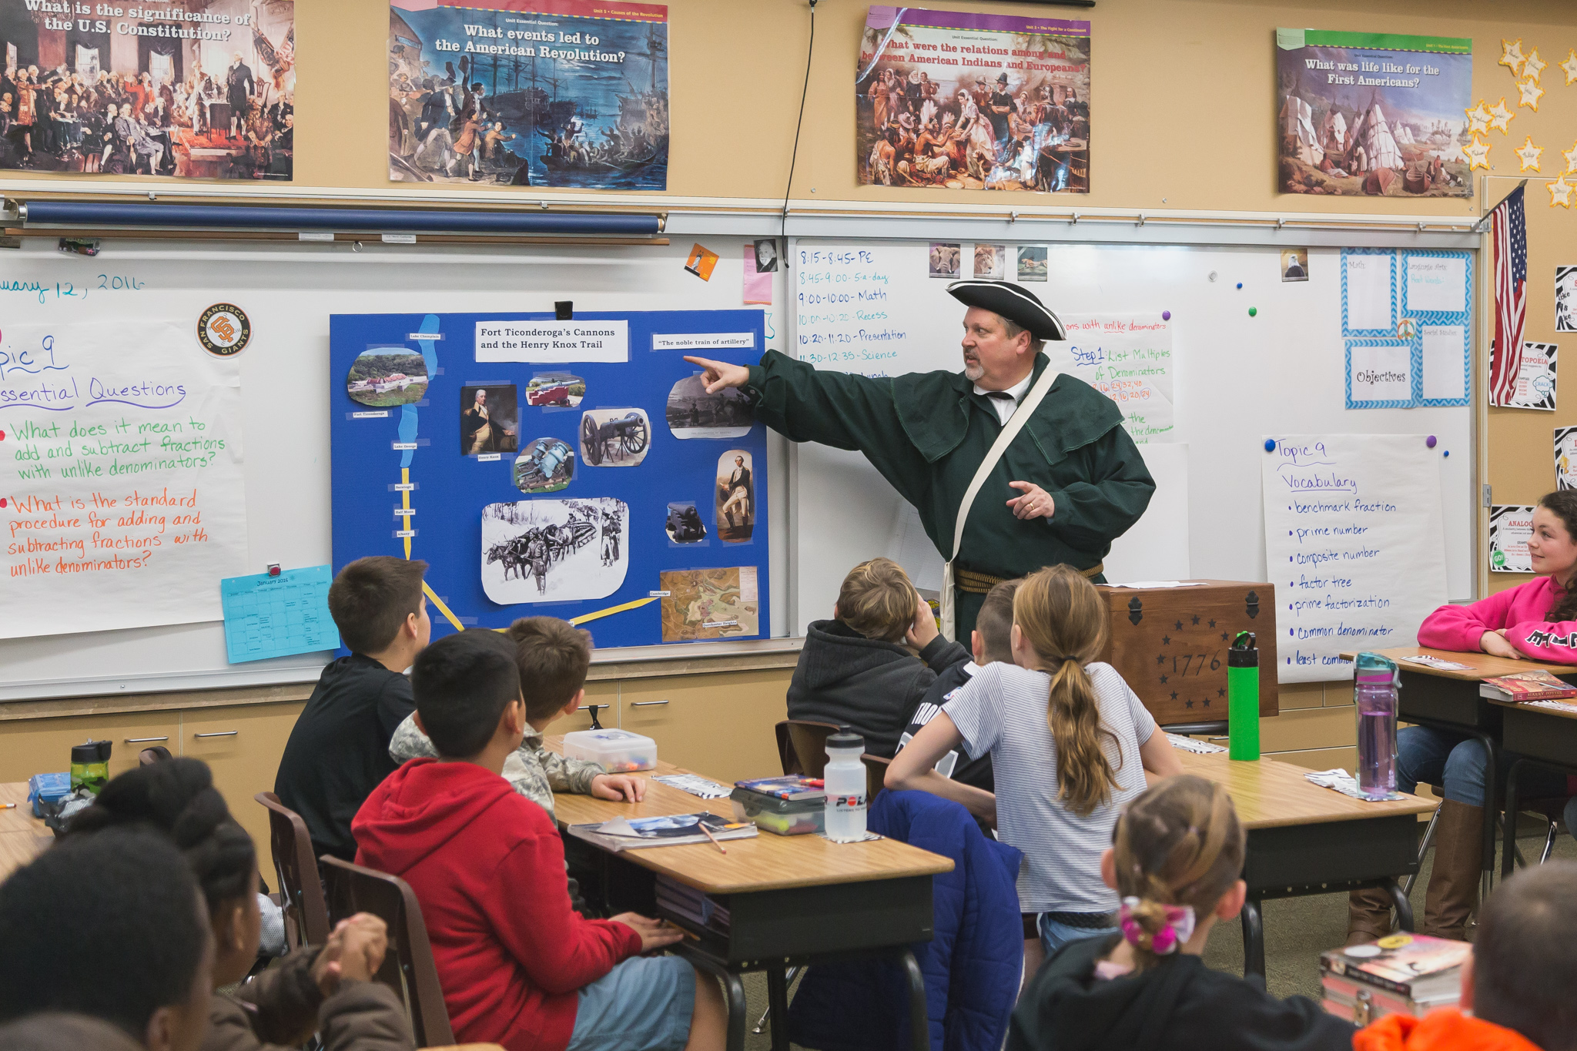  Sons of the American Revolution  American History Poster Contest  2018-2019 School year  Paul Revere and Sybil Ludington  Messengers for Liberty  Patriot messengers or couriers who rose by horseback played an important role in the founding of our country. | Bring American history alive for your 5th grade students  ────  This FREE program is offered as a public service to Teachers and Students  ────  SAR members are descendants of a patriot who fought or assisted the cause of American Independence.  Our experts will visit your classroom to discuss the annual topic and contest rules  Prizes are awarded at the local, state and national levels  To learn more go to GoldCountrySAR.com or email Dave Gilliard at: gilliardda@msn.com  Classroom visits will take place from December 2018 through January 2019

SAMPLE EMAIL TO TEACHERS

Dear Ms. Washington,

I am writing to invite your 5th grade class to participate in the Annual American History Poster Contest we sponsor as a public service at no cost to teachers or students. This national contest gives students learning American history the opportunity to learn about an important event from the American Revolution and win prizes at the local, state and national levels.

This year the poster topic is “Paul Revere and Sybil Ludington - Messengers for Liberty.” Early next year, one of our members who is well versed on the topic will visit your classroom, dressed in a Continental Army uniform or other style of colonial dress, and discuss the poster topic and rules. Over the years we have found that students especially enjoy seeing and asking questions about the uniforms or colonial attire.

You can find out more information about the contest by visiting www.CaliforniaSAR.org and clicking the “Programs” tab, then going to the “Youth and Educational Programs” section.

Youth educational programs are one of the primary functions of our 141 year old organization. Every year, thousands of California students participate in this contest and we hope you will consider our offer to include your class in 2018. If you have any questions, please feel free to contact me by email or phone.

Best regards,

Sam Adams
Independence Chapter, Sons of the American Revolution

