Joseph S. Rumbaugh Historical Oration Contest
The National Society of the Sons of the American Revolution (SAR) invites all high school students (9th through 12th grades) interested in the American Revolution to participate.

The contest is for an original speech, 5-6 minutes in length, focusing on:
an event, personality or document pertaining to the
American Revolutionary War
and show a relationship to America today.

Each student’s speech (and accompanying manuscript) will be judged based upon its composition, delivery, significance, and historical accuracy and relevance.

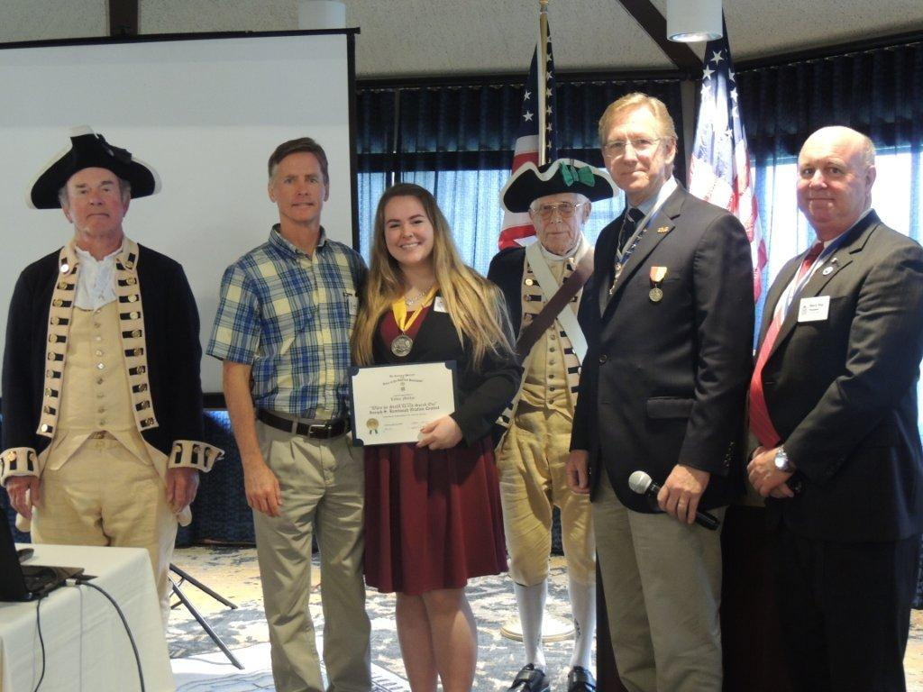

Recipient of the 2018 CA SAR Oration Contest

National First Place Winner receives $6,000, the 2nd Place Runner-up receives $4,000,
and the 3rd Place Runner-up receives $2,000.

California State Society First Place Winner receives $1,000.

Local Chapter Prizes vary.

Please see www.californiasar.org for all the rules. Deadline for this year’s contest is Friday, February 19, 2021. Questions? Contact John Ferris at jrf1776@outlook.com

