You’re Invited
FRIDAY EVENING NOV. 1- 6:30 – 9:00 pm
To an optional dinner and tour at The Automobile Driving Museum
only two blocks from The Hacienda Hotel (Board Of Managers Meeting venue)
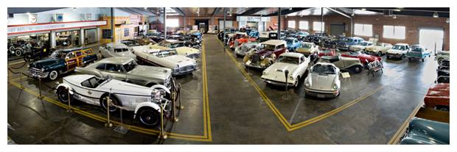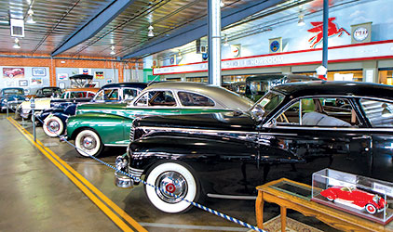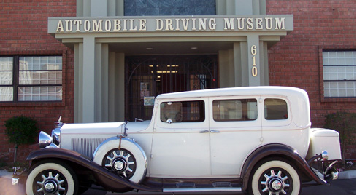

Featuring well over 100 Antique, Pristine, Classic Automobiles – with docent-led tours, this event will bring back memories long forgotten. Your fee for this OPTIONAL event includes the admission fee to the museum, private docent-led tours, AND a Buffet BBQ Ribs dinner to be served on-site. Please join us.
Vegetarian meals are available with prior notice.

All participants at the Board of Managers Meeting are cordially invited to attend. The fee for this tour and dinner is only $30.00 PER PERSON. Please indicate your interest by either mailing or the form below along with your check to the Harbor Chapter –
402 Hillcrest St., El Segundo, CA 90245-2911
- - - - - - - - - - - - - - - - - - - - - - - - - - - - - - - - - - - - - - - - - - - - - - - - - - - - - - - - - - - - - - - - -
PLEASE COUNT US IN FOR THIS DINNER AND TOUR

Your Name: ______________________________ Number of tickets needed: _______________________

I prefer ________ Vegetarian Meals.

Please put us on the list to attend. Our check for _____ participants ($30.00 each) is enclosed.

Your ticket for admission to the Friday Evening Dinner and Tour will be found in your Registration Packet – to be picked up at The Hacienda Hotel upon arrival.

If you have any questions, please do not hesitate to call 310-562-0614 or send an email to: karsar@earthlink.net.

Looking forward to seeing you at the California Society Sons of the American Revolution Annual Board of Managers Meeting November 1-2.

James Gill
President, Harbor Chapter SAR

