CASSAR Ladies Auxiliary
SPECIAL TOUR
Friday, November 1st from 1:30pm to 3:00pm

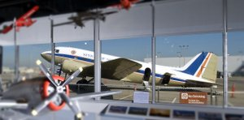

Please join the ladies of the California Society, Sons of the American Revolution on a FREE tour of the Flight Path Learning Center and Museum at LAX.

Los Angeles has a rich history in aviation and aerospace with Southern California companies playing important roles in the development of air and space flight. So, it’s not surprising that the area is rich with air and space museums. THE FLIGHT PATH LEARNING CENTER AND MUSEUM in the LAX Imperial Terminal on the south side of LAX houses exhibits of airline memorabilia from uniforms to historic ads and promotional items – including from now defunct airlines, a massive collection of model planes, and a fully restored luxury DC-3 that you can board. Please sign up for this FREE LADIES TOUR. A sign-up sheet will be available in the Hospitality Room.
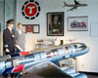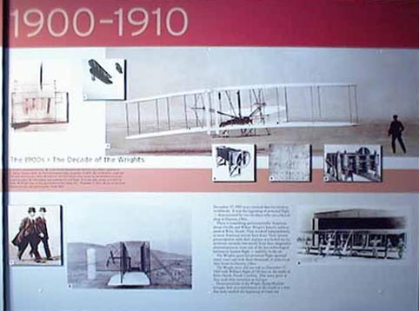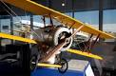

It would be nice to let the Museum know how many to expect before we get there on the 1st. Ladies, please send me a quick email saying “Yes, count me in for the Ladies Tour” if you are interested in this event. Send your email to karsar@earthlink.net.

