142nd Annual Meeting
of the
California Society, Sons of the American Revolution

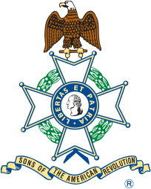

Wyndham Irvine Hotel
17941 Von Karman Avenue
Irvine, California
April 7 – 8, 2017
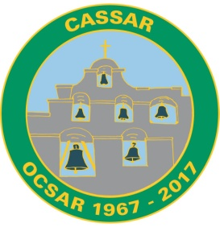
Schedule of Events

Thursday, April 6

4:00 p.m. – 10:00 p.m. Registration

4:00 p.m. – 11:00 p.m. Hospitality Suite open

6:30 p.m. NSSAR President General’s Dinner (by invitation only)

Friday, April 7
Breakfast on your own
8:00 a.m. - 9:00 a.m. Registration
9:00 a.m. - 11:45 a.m. Opening Ceremonies – Catalina 3
(NSSAR Color Guard Event)
Invocation, Presentation of the Colors,
Pledge of Allegiance, Pledge to the SAR,
Roll Call, Business Meeting Agenda
General Business Session – Catalina 3

9:00 a.m. - 11:45 a.m. Ladies Auxiliary Board Meeting – Avalon 2 & 3

12:00 noon – 2:00 p.m. Public Service Luncheon – Catalina 1 & 2
(Meal tickets required)
Quilts of Valor

2:15 p.m. – 3:30 p.m. General Business Session continues – Catalina 3
3:30 p.m. – 4:30 p.m. Ladies’ Low Tea – Avalon 2 & 3
C-Nile Sound Barbershop Quartet

3:30 p.m. – 4:30 p.m. Color Guard Workshop – Catalina 3

4:30 p.m. – 11:00 p.m. Hospitality Suite open, dinner on your own.
6:30 p.m. CASSAR Officers’ Dinner (optional)

Saturday, April 8

Breakfast on your own
7:15 a.m. – 8:15 a.m. Past State Presidents’ Breakfast – Paradise Café
7:30 a.m. – 8:30 a.m. Past Ladies’ Auxiliary Presidents’ Breakfast - Paradise Café
8:30 a.m. – 11:45 a.m. General Business Session – Catalina 3

8:30 a.m. – 9:30 a.m. Budget & Audit Committee Meetings - Executive Board Room

9:00 a.m. – 11:45 a.m. Ladies’ Auxiliary General Session – Avalon 2 & 3

12:00 noon – 2:00 p.m. Youth Awards Luncheon – Catalina 1 & 2
(Meal ticket required)

2:15 p.m. – 3:00 p.m. Memorial Service – Catalina 3
(NSSAR Color Guard Event)
Music by piano and violin

3:15 p.m. – 4;00 p.m. 2019 Congress Planning – Avalon 2 & 3

6:00 p.m. – 7:00 p.m. Social Hour – Cash bar available

7:00 p.m. – 10:00 p.m. Gala Inaugural Banquet – Catalina Ballroom
(Meal ticket required)
(NSSAR Color Guard Event)
From Lexington and Concord to Yorktown
Paul Revere’s Ride
Los Angeles Fifes and Drums
Remarks by General George Washington

10:00 p.m. – 11:00 p.m. Hospitality Suite open

Sunday, April 9

Hotel check-out by 12:00 noon

