A Low Tea

Hosted by the Orange County Chapter, California Society, SAR Ladies Auxiliary

3 pm, Friday, April 7, 2017 in Avalon Rooms 2 & 3, Wyndham Irvine Hotel, Irvine, CA.
The legend says that Low or Afternoon Tea was started by Anna, the 7th Duchess of Bedford (3 September 1783 – 3 July 1857). At the time, there were only two meals: Mid morning breakfast and late dinner.
Following the story, the Duchess was having a ‘sinking feeling’ in the late afternoon and as a solution she started having a pot of tea and a light snack in her boudoir in the afternoon. Later the Duchess decided to invite friends to join her in the sitting room where the food was served on low tables (coffee tables) placed next to sofas. Soon the idea spread and high society was sipping tea and eating nibbles in the afternoon.
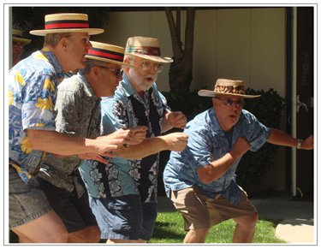
Join us for door prizes, your favorite tea, finger foods, a game of trivia with prizes, and entertainment by C-Nile Sound, a quartet with the Barbershop Harmony.
C-Nile Sound left to right: Bruce Beyne, Denny Lawrence, Rick Llewelyn, Karl Jacobs.
Please wear your spring colors and your Easter bonnet.

