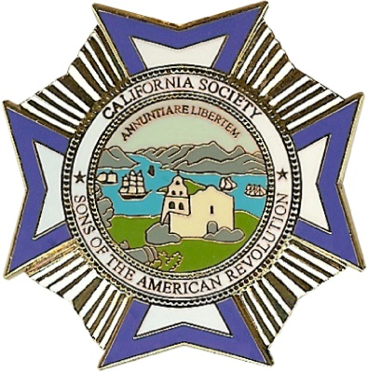

143rd Annual Spring Meeting
of the
California Society
Sons of the American Revolution
April 19 – 21, 2018

SCHEDULE OF EVENTS

Thursday, April 19

4:00 PM – 10:00 PM Registration – Main Lobby
4:00 PM – 10:00 PM Hospitality Room Open – Hospitality Room 1025-1027
6:30 PM Dinner on Your Own (NSSAR, by invitation only – Zio Fraedos)

Friday, April 20

8:00 AM – 10:00 AM Registration – Main Lobby
9:00 AM – 11:30 AM Opening Ceremonies – Seminar 4
Presentation of Colors, Invocation, Pledge of Allegiance, SAR Pledge
General Business Session – Seminar 4
Ladies Axuiliary Board Meeting – Seminar 2
NOON – 2:00 PM Public Service Luncheon – Park Room
(meal ticket required)
2:15 PM – 3:30 PM General Business Session Continues – Seminar 4
2:30 PM – 4:30 PM Ladies Tour (Galindo House) – meet in Hotel Lobby
3:30 PM – 4:30 PM Workshops (if needed) – Seminar 3
4:30 PM – 10:00 PM Hospitality Room Open – Hospitality Room 1025-1027
6:00 PM Dinner on Your Own (President’s Dinner – Scott’s)

Saturday, April 21

7:15 AM – 8:15 AM Past State Presidents Breakfast – PV Main Dining Room
7:15 AM – 8:15 AM Past Ladies Auxiliary President’s Breakfast – PV Main Dining Room
8:30 AM – 9:00 AM Budget & Audit Committee Meeting – Executive Board Room
9:00 AM – 11:30 AM General Business Session – Golden Gate D/E
Board of Managers Meeting – Golden Gate D/E
Western District Meeting – Golden Gate D/E
9:00 AM – 11:30 AM Ladies Auxiliary General Session – Seminar 2
9:30 AM – 11 AM Poster Contest Judging – Please Vote – Golden Gate D/E
NOON – 2:00 PM Youth Awards Luncheon – Golden Gate C
(meal ticket required)
2:15 PM – 3:00 PM CASSAR Memorial Service – Park Room
3:00 PM – 4:00 PM OFNA – Seminar 2
4:00 PM – 5:00 PM Society of Colonial Wars – Seminar 2
3:30 PM – 5:00 PM Hospitality Room Open – Hospitality Room
6:00 PM – 7:00 PM Social Hour
7:00 PM – 10:00 Gala Inaugural Banquet – Golden Gate C
(meal ticket required)
10:00 PM – 11:00 PM Hospitality Room Open – Hospitality Room 1025-1027

Sunday, April 22

Hotel Check Out by NOON

