146th Annual
Fall Board of Managers Meeting
of the
California Society, Sons of the American Revolution

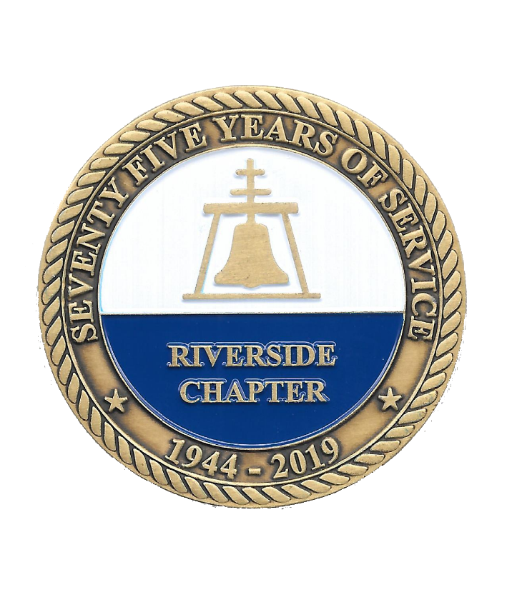

The Mission Inn
3649 Mission Inn Avenue
Riverside, California
November 4 - 7, 2021
Schedule of Events
Thursday, November 4

4:00 p.m. – 10:00 p.m. Registration – Suite 401

4:00 p.m. – 10:00 p.m. Hospitality Room open – Suite 401

5:00 p.m. – 8:00 p.m. Mission Inn Tours – starting in the lobby on the hour

5:00 p.m. – 10:00 p.m. Dinner on your own
or
6:00 p.m. – 9:00 p.m. National Officers Dinner – Santa Barbara Room – Mission Inn
(Invitation Only)

Friday, November 5
Breakfast on your own
8:00 a.m. - 9:00 a.m. Registration – Galleria
9:00 a.m. - 11:45 a.m. General Business Session – Galleria
Business Meeting Agenda

9:00 a.m. – 11:45 a.m. Ladies Auxiliary Board Meeting – Dignitaries Parlor

12:00 noon – 2:00 p.m. Public Service Luncheon – Spanish Art Gallery
(Meal tickets required)

2:15 p.m. – 4:00 p.m. General Business Session continues – Galleria

2:30 p.m. – 4:30 p.m. Ladies’ Event: Museum Tour – Meet in Lobby

4:30 p.m. – 11:00 p.m. Hospitality Room open – Suite 401

5:00 p.m. – 10:00 p.m. Dinner on your own,
or
6:00 p.m. – 9:00 p.m. California Society, SAR Officers’ Dinner
Old Spaghetti Factory – walking distance
(Advanced reservation required)
Saturday, November 6

Breakfast on your own
7:30 a.m. – 8:30 a.m. Past State Presidents’ Breakfast – Mission Inn Restaurant Executive Corner - Patio Alcove outside Spanish Library
9:00 a.m. – 11:45 a.m. General Business Session continues – Galleria
National Officer Candidate Forum

9:00 a.m. – 11:45 a.m. Ladies’ Auxiliary General Session – Renaissance Salon

12:00 noon – 2:00 p.m. Chapter Awards Luncheon – Spanish Art Gallery
Valley Forge Teacher
(Meal ticket required)

2:15 p.m. – 4:30 p.m. General Business Session continues - Galleria
Western District Meeting

4:00 p.m. – 5:30 p.m. Hospitality Room open – Suite 401

6:00 p.m. – 7:00 p.m. Social Hour – Spanish Library Patio - Cash bar available

7:00 p.m. – 10:00 p.m. Formal Banquet – Spanish Art Gallery
Remembering The Times That Tried Mens Souls
(Meal ticket required)

10:00 p.m. – 11:00 p.m. Hospitality Room open – Suite 401

Sunday, November 7

9:30 a.m. – 2:00 p.m. Mission Inn Restaurant - Sunday Brunch
(On your own and reservations advised)

10:00 a.m. – 11:30 a.m. Hosting Committee Debrief - Mission Inn Restaurant
(Invitation Only)

12:00 p.m. Hotel check-out

