147th Annual Spring Meeting

of the

California Society
Sons of the American Revolution

April 21–24, 2022

Holiday Inn Sacramento Downtown – Arena
300 J Street, Sacramento, CA 95814
916-446-0100
Reservation link: 2022 BOM Spring Meeting
The group code is: BOM

Hosted by the Sacramento Chapter
President, Michael Hull
(Email paddle@frontiernet.net)

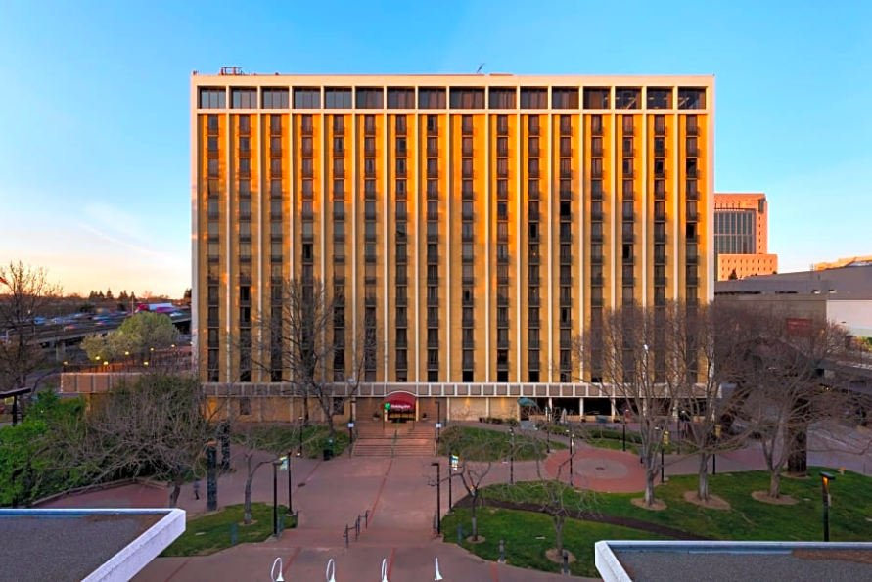

The Holiday Inn Downtown-Arena is within walking distance of many fantastic Sacramento venues. Golden 1 Arena, DOCO-Downtown Commons, Historic Old Sacramento, Railroad Museum, State Capitol, Federal Courthouse, and many more. Lots of shopping, restaurant, and museum options.

