New Member Manual

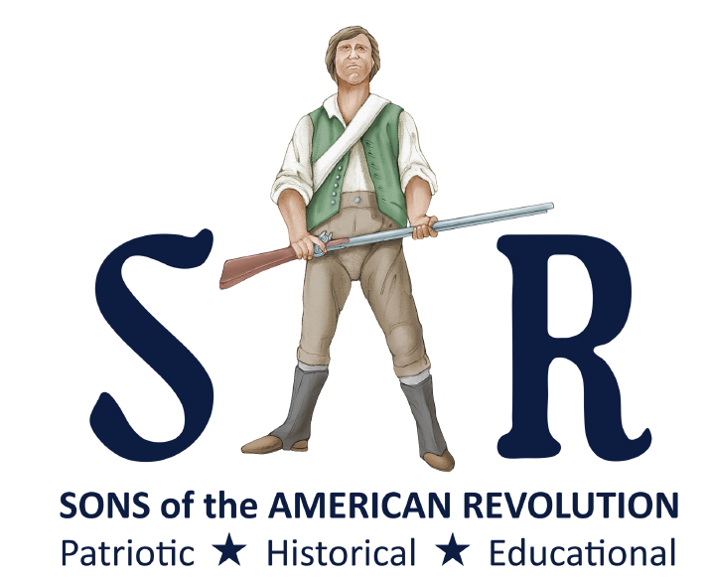

www.sar.org

Contents

Welcome…………………………………………………………………3
Brief History of SAR…………………………………………………….3
Brief Summary of Organizational Structure……………………………..3
Common Terms Defined………………………………………………....4

Compatriot
Membership Categories
SAR
SAR Member Badge
SAR Rosette
Annual Congress
General Officer
Trustee
Board of Trustees
State Society
Chapter
District
Leadership Meeting
SAR Education Center and Museum
SAR Color Guard
Ladies’ Auxiliary

Basic Protocol……………………………………………………………5
Attire
Insignia
Medals

Opportunities …………………………………………………………….6

Activities…………………………………………………………………6

Resources………………………………………………………………...7

Welcome, Compatriot! As a new member of the National Society of the Sons of the American Revolution you have joined the largest male lineal society in the United States which is dedicated to furthering understanding of the American Revolution and its significance past, present, and future. SAR is chartered by the United States Congress, signed into law by Compatriot President Teddy Roosevelt. You are encouraged to actively participate in the brotherhood and patriotic service of the society.

Brief History of SAR
The first effort to organize descendants of Revolutionary War, occurred in San Francisco, in 1875. This was in anticipation of the centennial of the revolutionary War. The first official meeting was June 29, 1876. The group attracted about 80 men and the group named themselves “Sons of the Revolutionary Sires”. They marched in the July 4^{th,} 1876, parade in San Francisco. The organization fell in numbers over the years.

In 1883, the New York Society of the Sons of the American Revolution was organized by John Austin, this could be traced as the founding of the Sons of the American Revolution.

William Osborn McDowell with Josiah Pumpelly and William Stryker, all who were members of the New York Society, organized the New Jersey Society of the Sons of the American Revolution in 1889. They refused to accept being subordinate to the New York Society. After approaching other states to organize societies, the Sons of the American Revolution were organized at the Fraunces Tavern in New York on April 30, 1889, the centennial of George Washington’s inauguration.

The National Society of the Sons of the American Revolution was incorporated on January 17, 1890, in Connecticut, with the first National Congress on April 30, 1890, in Louisville, Kentucky. A congressional charter was granted on June 9, 1906, and signed by President Theodore Roosevelt, a member of the SAR.

Brief Summary of Organizational Structure
The National Society is organized into State Societies. Membership in the National Society Sons of the American is through a State Society—there are no National at-large memberships in SAR! State Societies are organized into Chapters which is the level through which membership is attained. State Societies receive their charters from the National Society which is chartered by an act of the United States Congress (36 U.S.C. Chap. 1533). State Societies and Chapters which are chartered by State Societies must comply with all National Society policies which are outlined in the multivolume SAR Handbook. State Societies are further organized by the National Society into Districts for cooperation and mutual support of the National Society’s mission. All members are required to pay annual Chapter, State, and National dues to retain membership.

Common Terms Defined:
Compatriot is the official designation of a member of the National Society of the Sons of the American Revolution.
Membership categories are Regular Member or Regular Life Member the age of 18 years and older, Junior Member under the age of 18 years, and Memorial Membership for a deceased male of the same family as current members.
SAR (always pronounced as letters, never as a one syllable term) is the acronym for National Society of the Sons of the American Revolution.
SAR Member Badge is worn by a compatriot at SAR functions and when representing the SAR. It is a Maltese cross of four arms and eight points with a bust of George Washington at its center and available from the SAR Store at https://store.sar.org/product/member-badge .
SAR Rosette is worn by a compatriot, at his discretion, on the left lapel of his jacket, but is not worn simultaneously with the SAR Member Badge. It may be purchased from the SAR Store at https://store.sar.org/product/member-rosette .
Annual Congress, sometimes simply called “Congress,” is the yearly convention of the National Society hosted by a State Society. State Societies select delegates based upon its membership but every compatriot is welcome to attend; spouses and family members are also welcome.
General Officer is the term given to the National Society officers elected at the Annual Congress to one year terms. The President General is the Chief Executive Officer of the National Society, followed in descending rank by Secretary General, Treasurer General, Chancellor General, Genealogist General, Registrar General, Historian General, Librarian General, Surgeon General and Chaplain General. A Vice President General is nominated by each District (see below) and elected at Congress.
Trustee is the member nominated by his State Society to serve a one year term and is elected at the Annual Congress to serve on the Board of Trustees; General Officers, Executive Committee Members and former Presidents General are also elected to the Board of Trustees.
Board of Trustees manages the business and affairs of the National Society and is the custodian of all National Society property; each State Society is represented by one Trustee.
State Society is chartered by the National Society in any State or Territory, including any foreign country, in which a Society does not exist.
Chapter is the local organization chartered by a State Society to promote growth in membership and interest in the objects of the National Society.
District is group of State Societies served by a Vice President General to strengthen the constituent State Societies.
Leadership Meeting is each fall and spring in Louisville, KY at which National committees meet to make recommendations and the Board of Trustees manages the business and affairs of the National Society.
SAR Education Center and Museum is at 809 West Main, Louisville, KY. SAR is active in education and raising funds to complete the SAR Education Center and Museum.
SAR Color Guard is the compatriots who attend SAR meetings and events properly uniformed as either Continental Soldiers or Militiamen, or attired as Revolutionary-era clergymen.
Ladies’ Auxiliary provides assistance to SAR at Chapter, State Society, and National Society levels. Membership is open to ladies who are related by marriage or blood line to SAR Members in good standing.

Basic Protocol
Attire: Each chapter varies in expected attire at meetings influenced by their meeting location and/or climate. Period attire (Continental Army, Militia, and period civilian clothing) are always acceptable, including formal events. The basic attire for State and National meetings is coat (normally navy blazer), shirt, and tie. State and National meetings often include formal banquets which should indicate Black Tie or White Tie on the schedule.
Insignia: Every member when attending an SAR event/meeting or representing the SAR at a public event is entitled to wear the National Society Sons of the American Revolution insignia which can be purchased from the store on www.sar.org (registering on the member web site is required). The insignia is worn on a blazer or suit coat (never an overcoat) on the left breast suspended on the included drape. Current and Former General Officers, State Presidents, and Chapter Presidents may wear the insignia suspended from the SAR Neck Ribbon.
Medals and Awards: Medals are presented by the National, District, State, or Chapter level according to criteria published in The SAR Handbook, Volume V. They may be worn at an SAR event/meeting or when representing the SAR at a public event. Mounting medals when the compatriot has earned three or more is recommended according to the criteria in The SAR Handbook. Volume IV.

Opportunities

At the national level members can attend the annual congress and the leadership meetings held twice a year in Louisville, Kentucky. Delegates for congress are appointed from each state which enables a member to vote for new officers, bylaws and financial requests. There are also events for the ladies, tours of historical points of interest, banquets and the chance to meet compatriots from other states and countries.

Leadership meetings enable members to attend committee meetings and join committees. Trustees are elected from each state society and vote for SAR business matters. Committees are the working basis of SAR. Some of these committees are Education, Color Guard, Americanism, Veterans, Historic Sites and Youth Programs. A complete list of committees and their goals can be found on the SAR website.

Activities

At National, District, State and Chapter levels there are numerous activities to support. Color Guard presents a great opportunity for the SAR to be visible to the public. The Color Guard marches in parades such as July 4, Memorial Day and Veterans Day. They participate in Grave Marking for Patriots and other events such as History Day in some states. Points are awarded for events and Color Guardsmen can earn medals.

Compatriots may participate with committees such as ROTC/JROTC, Eagle Scouts, Oration, Essay, Poster and History Teacher. These committees conduct patriotic education contests through which youth earn awards and medals relating the significance of the American Revolution to current day issues.

Educational programs are presented about the Revolutionary War in schools and other venues.

Public Service medals are awarded for outstanding service in Law Enforcement, Fire Safety, and Emergency Medical Services. Medals are also awarded to citizens for Life Saving and Heroism as well as Good Citizenship.

Wreaths Across America is a program to place wreaths on veterans graves at National Cemeteries.

Compatriots work with the Children of the American Revolution (C.A.R.) and support their activities.

DAR (Daughters of the American Revolution-formed 1890) is supported by the SAR in various ways such as providing a Color Guard.

Flag certificates are awarded to those who fly the American Flag in a respectful way.

SAR supports our veterans with Ancestor Search to help them discover their ancestors.

SAR, state societies and chapters have websites with information on dates, times and locations of activities to keep members informed of events. A more complete listing of activities can be found on their websites.

Resources

The best source of information is the SAR web site: www.sar.org . You need to register an account with your private login to access the member only resources at:
https://members.sar.org/login?_redirect=//sar.org

SAR Handbook, Volumes I-VIII
https://sar.org/compatriots/member-tools/sar-handbook
Volume I, Governing Documents
Volume II, Organization
Volume III, Membership, Compliance, & Other Policies
Volume IV, Insignia, Protocol, Ceremonies & Rituals
Volume V, Individual Medals and Awards
Volume VI, Youth Programs, State Society & Chapter Awards
Volume VII, Summary History of the Sons of the American Revolution
Volume VIII, Historical Roster of SAR General Officers

Color Guard Handbook:
https://members.sar.org/media/uploads/pages/201/E2YTwVFUMOkY.pdf

Education: https://www.sar.org/education/sar-outreach-education

SAR Magazine (current and archived issues):
https://www.sar.org/compatriots/sar-magazine

Your State Society web site which can be linked from:
https://www.sar.org/state-websites.
Many State Societies have links on their web site to Chapter web sites.

Your Chapter officers:

