Contests and Awards for Students

Each school year, SAR sponsors contests to recognize students for writing or speaking Excellence on Revolutionary War topics and historical themes. Students can write essays, deliver live speeches, or make posters or brochures to compete.

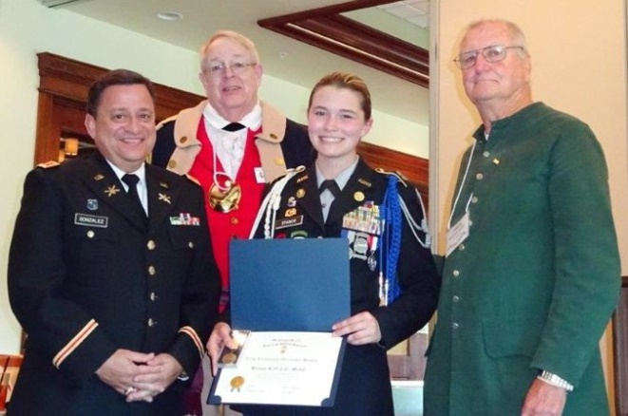

We sponsor a Junior ROTC contest working with faculty advisors. The SAR sponsors chapter and state contests to recognize the achievements of members of the state’s Junior ROTC units. The competition involves writing an essay and getting their advisor’s recommendation showing how his or her Junior ROTC membership has made the candidate a better citizen.

LOCAL CHAPTER:

Local Chapter email/phone

____________________________________

____________________________________

We honor Eagle Scouts

Eagle Scouts receive forms to enter a contest for recognition and potential scholarship monies.

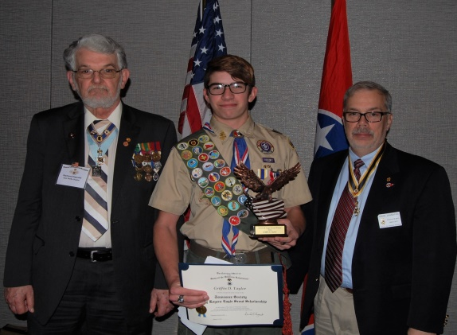

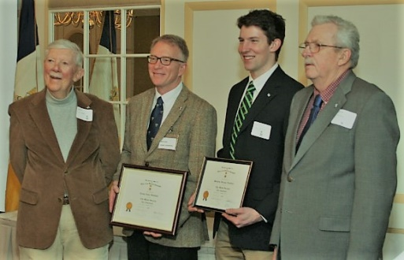
How to become a member
Membership is open to any male (no age limit) who can prove direct descent from a man or woman who contributed to our country’s freedom from Great Britain. A patriot did not necessarily have to serve in the military, but might have supported the Revolution by paying a supply tax, providing food for troops, serving as a juror, or being a local public servant.
You will need to document your lineage back to the qualifying ancestor. Acceptable sources for proof are vital records, census records, probate records, wills, family Bibles, and letters. Your local chapter registrar will help you locate the proofs. Please see the contact information below to get started. We’re here to help!

The SAR website is SAR.org . See the website to view the process to membership.

Sons of the American Revolution

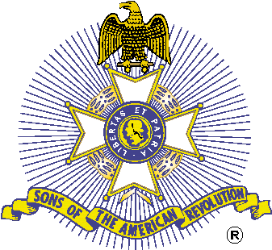

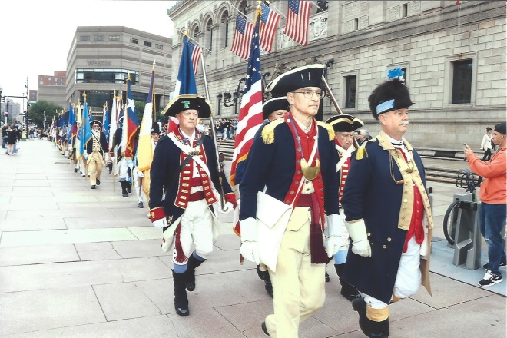
Who We Are
The Sons of the American Revolution is a non-political, patriotic, educational 501c3 organization of men who have ancestors who fought for, or otherwise supported the War For Independence from Great Britain that established the United States of America.
- Working to preserve our nation’s past
- Assisting schools, teachers and the public
- Sustaining and preserving our history and constitutional principles.

We remember the past
By honoring those who served or assisted the colonies during the Revolutionary War.

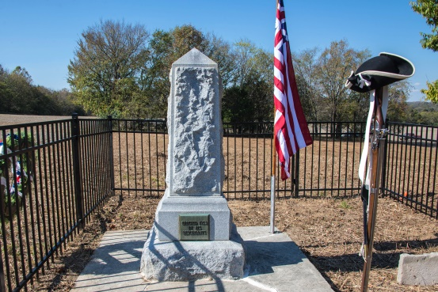

We honor our military
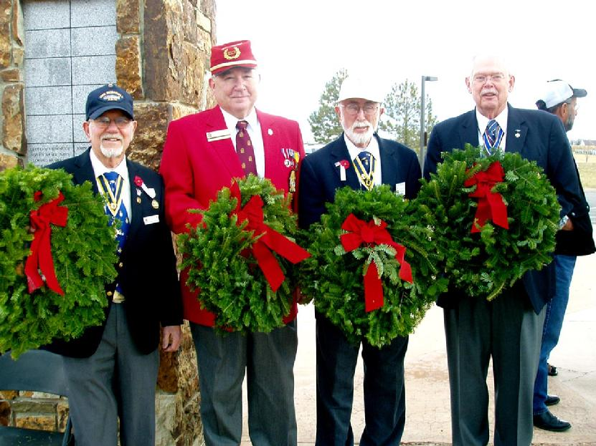

We promote patriotism
Color Guard members put “colors” on display
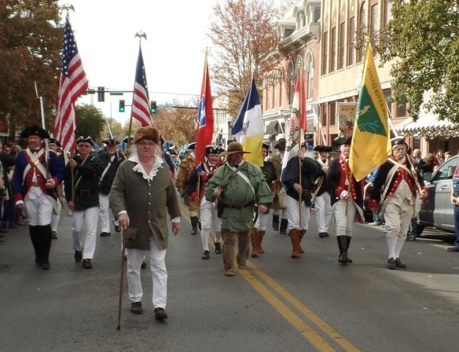

We honor those who fly the flag
The SAR searches for people and businesses that proudly display the American Flag.
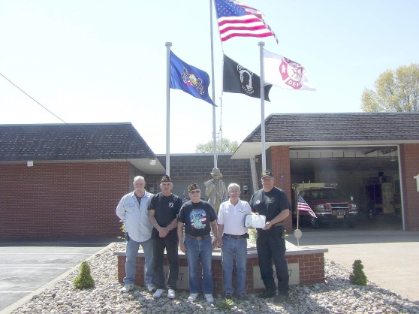

We have great history teachers
Each spring, SAR chooses an excellent teacher of American History by naming a Teacher of the Year
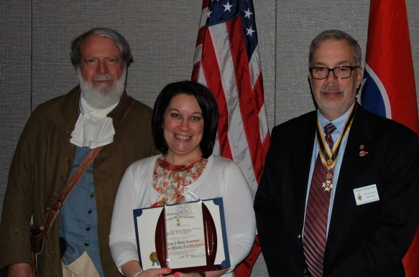

SAR Genealogy Research Library
Materials are available for genealogy research.
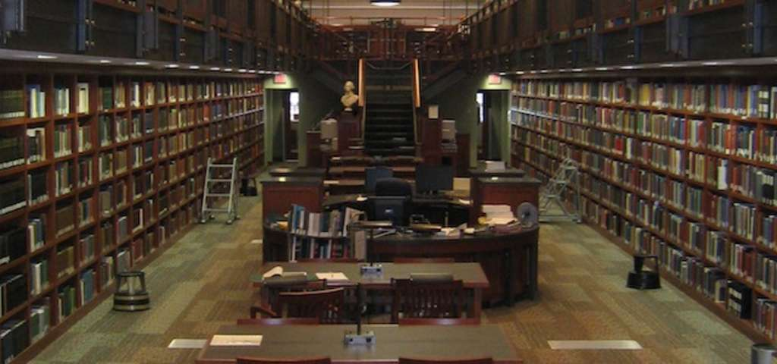

Shaping the young
By educating our youth about the Constitution and those who developed the American ideals and traditions. SAR members wear uniforms or other colonial attire and travel to schools to educate children about the birth of our country.
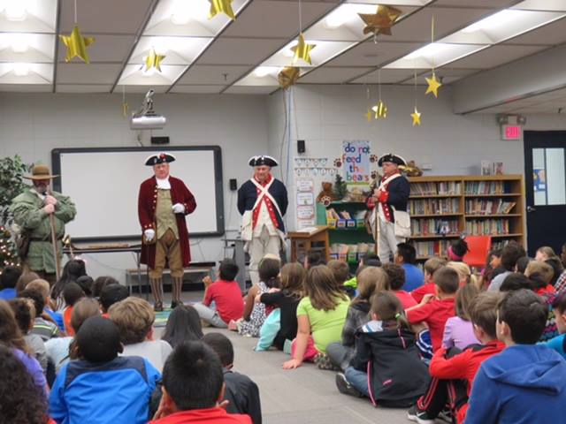

Citizenship
Each spring on the recommendation of local high school principals, seniors are recognized for displaying outstanding citizenship in their school and community.
